1.What are the two values of the Boolean data type? How do you write them?

*Solution: True and False (T and F are Capital case and rest are in lower case)*

*The output <class=’bool’> indicates the variable is a Boolean data type.*

2. What are the three different types of Boolean operators?

*Solution: and, or & not*

3. Make a list of each Boolean operator's truth tables (i.e. every possible combination of Boolean values for the operator and what it evaluates).

|  |  |  |
| --- | --- | --- |
| and | or | not |
| True and True  True and False  False and True  False and False | True or True  True or False  False or True  False or False | not True  not False |

4. What are the values of the following expressions?

(5 > 4) and (3 == 5) -> True

not (5 > 4) -> False

(5 > 4) or (3 == 5) -> True

not ((5 > 4) or (3 == 5)) -> False

(True and True) and (True == False) -> False

(not False) or (not True) -> True

Screenshot below for test results.

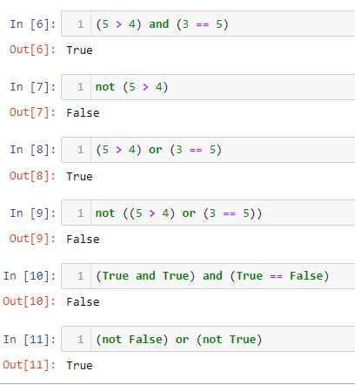

5. What are the six comparison operators?

|  |  |
| --- | --- |
| Operator | Description |
| == | Equivalent |
| != | Not Equivalent |
| > | Greater than |
| < | Lesser than |
| >= | Greater than Or Equal to |
| <= | Lesser than Or Equal to |

6. How do you tell the difference between the equal to and assignment operators?

Describe a condition and when you would use one.

The “=” operator is an assignment operator is used to assign the value on the right to the variable on the left.

Example : a= 10, b=20.23, c=”myname”

The “==” operator verify whether the two given operands are equal or not. If correct it returns True, else False.

Example:

a=5

if( a==5):

print(“True”)

else:

print(“False”)

7. Identify the three blocks in this code:

spam = 0

if spam == 10:

print('eggs')

if spam > 5:

print('bacon')

else:

print('ham')

print('spam')

print('spam')

*Solution:*

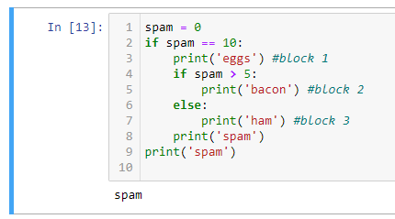

8. Write code that prints Hello if 1 is stored in spam, prints Howdy if 2 is stored in spam, and prints Greetings! if anything else is stored in spam.

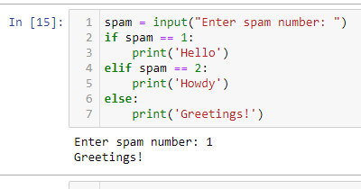

9.If your programme is stuck in an endless loop, what keys you’ll press?

*Solution: press Ctrl-C to force it to exit*

10. How can you tell the difference between break and continue?

|  |  |
| --- | --- |
| Break | Continue |
| This statement terminates the smallest enclosing loop (i.e., while, do-while, for loop, or switch statement) | This statement skips the rest of the loop statement and starts the next iteration of the loop to take place |
| When a break statement is encountered then the control is exited from the loop construct immediately. | When the continue statement is encountered then the control automatically passed from the beginning of the loop statement. |
| **Syntax:** break; | **Syntax:** continue; |

11. In a for loop, what is the difference between range(10), range(0, 10), and range(0, 10, 1)?

*The range() function returns a sequence of numbers, starting from 0 by default, and increments by 1 (by default), and stops before a specified number.*

|  |  |
| --- | --- |
| Syntax | Description |
| *range(10)* | *The range(10) call ranges from 0 up to (but not including) 10* |
| *range(0, 10)* | *The range(0, 10) explicitly tells the loop to start at 0* |
| *range(0, 10, 1)* | *The range(0, 10, 1) explicitly tells the loop to increase the variable by 1 on each iteration.* |

12. Write a short program that prints the numbers 1 to 10 using a for loop. Then write an equivalent program that prints the numbers 1 to 10 using a while loop.

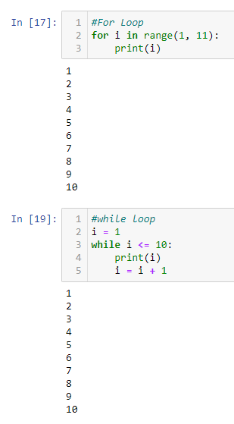

13. If you had a function named bacon() inside a module named spam, how would you call it after importing spam?

*Solution : We can call the function as spam.bacon().*